**Climada_measures_viewer manual**

**Intro:**

The *climada_measures_viewer* is a GUI (graphical user interface) for plotting inputs (assets) and results (damage and benefit) produced by *climada.* It requires a measures_impact .matfile (e.g. calculated by the function *climada_measures_impact* or *salvador_calc_measures*). The entire results produced using *climada* to conduct the methodology *economics of climate adaptation* on a specific region can be visualized as graphs or in *google earth.*

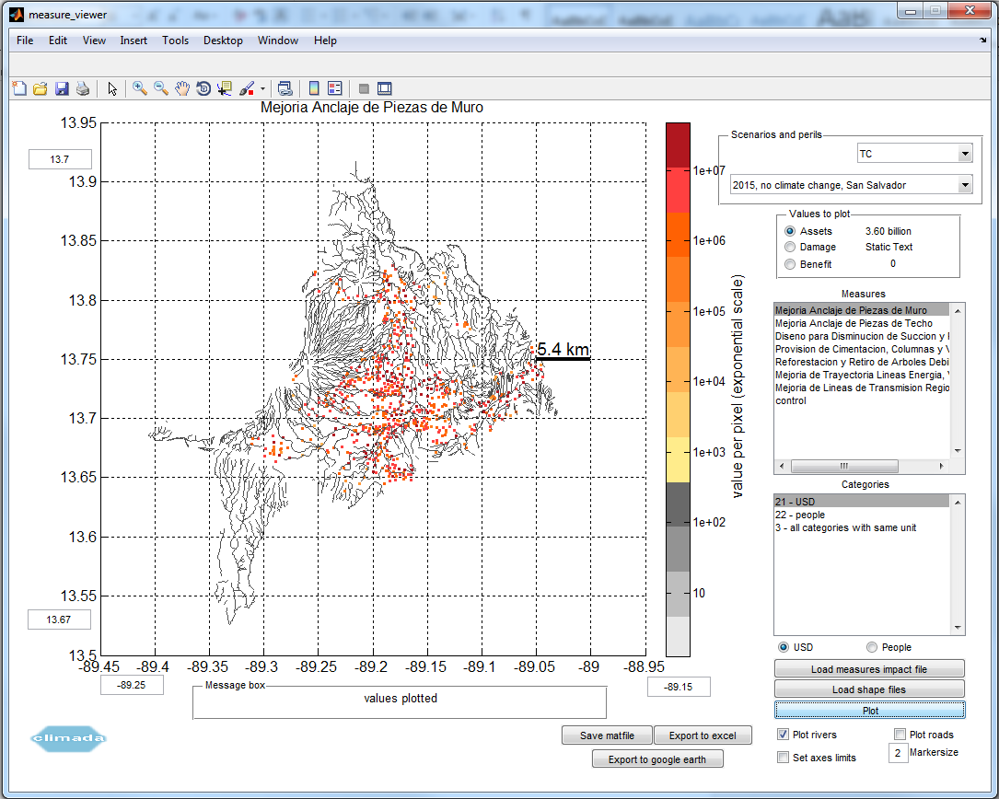

*Fig.1 The graphical user interface showing the assets (USD) used for calculating the tropical cyclone damage at the current state and the rivers.*

**Folder structure:**

The functions and the GUI of the *climada_measures_viewer* are located in the code folder. In the data folder, example measures impact files for each peril and a combined file are located in the folder 'results'. A set of shape files (roads, rivers) are also provided in the 'results' folder.

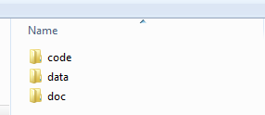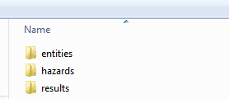

*Fig.2 The basic folder structure.*

To make these files faster available, copy them into the climada -> data folder, subfolder entities (respectively results), as the load function will look here for the files by default.

**Loading data:**

The GUI is started by running the *climada_measure_viewer.m* file after climada startup has been initialized. As files can get quite big >500 MB and to not push the users patience to much, a window shows the loading time.

* Base files:

First of all, a set of an *impact_measures*.mat file. This can be done using the "Load measures impact file" button. A popup menu will appear and ask for the *impact_measures* file. The perils are recognized automatically.

* Shape files:

Using the button "Load shape files", an ensemble of shape files can be loaded. They should be placed in the results folder, as this is where the function will start looking.

**Plot settings:**

To obtain a graph with the spatial distribution of the selected values, the following options need to be selected.

* Scenarios and perils:
  + In the first box, select one of the perils that is recognized automatically
  + In the second box: Select a scenario that is recognized for the chosen peril.
* Values to plot:
  + Assets: Selects the assets that apply for the specific scenario, category and measure
  + Damage: Selects the damage that apply for the specific scenario, category and measure
  + Benefit: Selects the benefits that apply for the specific scenario, category and measure
* Measures: A list with the measures to select from.
* Categories:
  + A list with the categories that can be selected. Recognizes automatically if the unit "USD" or "people" apply.

If "all categories with same unit" is selected, one has to also select "USD" or "people" and all categories with the specified unit are selected. The category should be chosen by double clicking on it.

**The plotting:**

After the selection, the graph is shown by pressing the "plot" button.

* Plot rivers: The shape file for rivers (if loaded) is shown, too.
* Plot roads: The shape file for roads (if loaded) is shown, too.
* Markersize: The size of the plotted points can be changed, default is 2.
* Set axes limits: On the left and the bottom side of the graphic field 2 boxes each can be seen: A lat/ lon value can be entered here (point separated) and registered by pressing enter. By selecting the "set axes limits" box, the plot shows the same figure in the limitations entered. Some graphs are stretched automatically, which can be undone by this.

**Additional options:**

* Save matfile: Asks to enter a *name* and then saves the current selection as *name*.mat file to the current working directory.
* Export to excel: After specifying the name two times, (first time to save the ".mat" file, second time as name for the ".xls" file) saves the current selection as *name.xls* file to the current working directory.
* Export to google earth: Produces a ".kmz" file that can be viewed with google earth.

Attention: The geolocation has usually a fine offset that can be fine-tuned in the code in the kml / kmz section. The axes limits for the kmz plot are predefined. The kmz file is stored in the folder climada -> results.

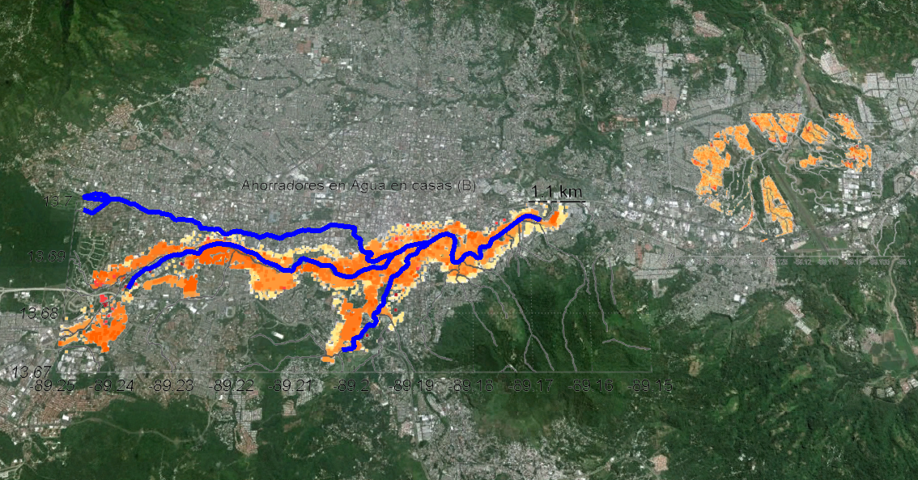

*Fig.3: The projections of flood and landslide assets on a google earth layer and highlighted rivers in a study region.*

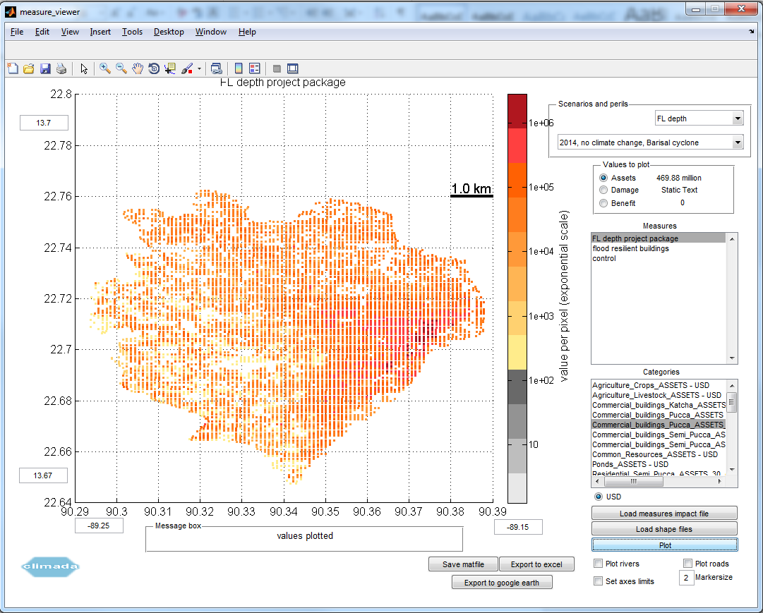 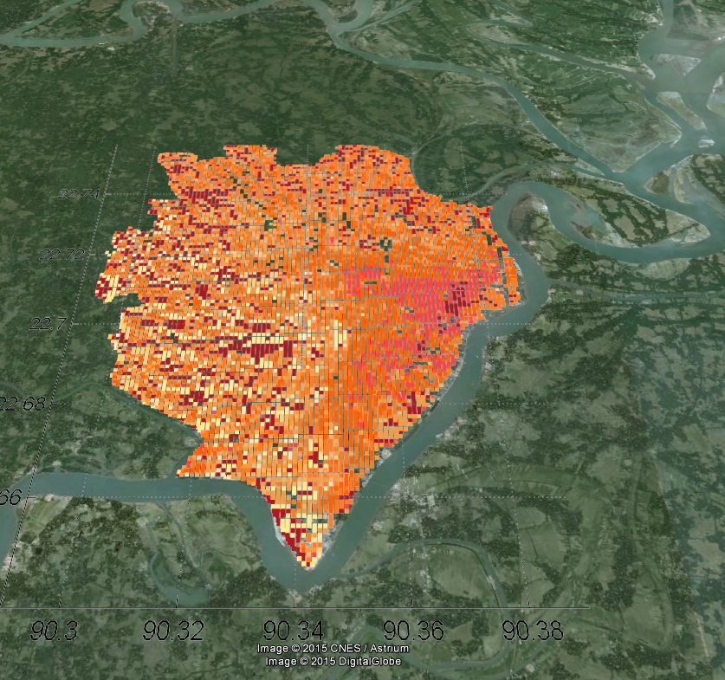

Fig.4: The assets used to calculate flood damage in a region in Bangladesh in the GUI and in google earth.